BIOC 404 – NTC Charles Vadnais
January 30th, 2006 – Lecture 12

Fluorescence

Note: The pair of terms “excitation” and “absorption” and the pair “fluorescence” and “emission” each refer to the same thing.

The fluorescence cycle

0- At the start of the cycle, the fluorescent molecule (or chromophore) is in the equilibrium ground state.
1- Excitation: The chromophore then becomes excited to a higher electronic state by a photon (of energy hν_{exc}) which is at the excitation wavelength of the fluorescent molecule (λ_{exc)}. The time scale for this event is on the order of 10⁻¹⁵ secs. The molecule moves to the Franck-Condon excited state.
2- The chromophore loses energy and moves from the Franck-Condon excited state to the equilibrium excited state by a process called relaxation. Relaxation takes between 100 picoseconds to 1 nanosecond (10⁻¹⁰ to 10⁻⁹ secs). Relaxation is detailed later in this lecture.
3- Emission: The chromophore releases energy either by emitting a photon at a new wavelength (λ_{emi}) or, as a competing process, by radiation-less processes (This will be detailed in later classes). The chromophore moves down to the Franck-Condon ground state. This process takes 10⁻¹⁵ secs.
4- The chromophore loses energy and moves from the Franck-Condon ground state to the equilibrium ground state, again by the process of relaxation.

The period between absorption and release of energy is in the order of nanosecs (10⁻⁹).

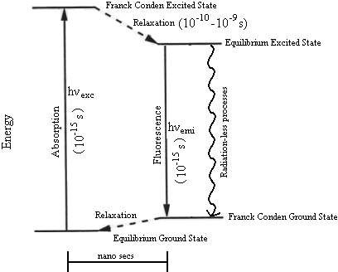
The Franck-Condon principle

The Franck-Condon principle states that excitation and emission events occur so quickly (10⁻¹⁵ secs) that the movement of the molecules and their nuclei is negligible. Only the electrons of the chromophore move on this time scale.

Note that the magnitude of the energy jump is larger than the magnitude of the energy drop. Also, relaxation can only take the system to a lower level of energy, or at worst, to a level of equal energy.

Therefore we can state: hν_{exc} ≥ hν_{emi} and since (λ = hc/ ν ), it follows that λ_{exc} ≤ λ_{emi}

Because the energy of excitation is always greater or equal to the energy of emission, the wavelength of emission (or fluorescence) will always be greater or equal to the wavelength of absorption. (In fact, most of the time, λ_{emi} is less than, not equal to λ_{exc)}

The consequence of having fluorescent light at a longer wavelength than the excitatory light is that by using appropriate filters, we can block out all light that was shined on a sample (including scattered light or other random sources) and detect only light emitted by fluorescence, even if that amount of light is as much as 10⁶ folds less than the light shined on a sample.

Relaxation:

Relaxation is the process by which excited molecules lose excess energy, which they have in two forms:
1- Vibrational energy levels within the excited state.
2- Non-optimal solvent-molecule dipole interactions (This only occurs with polar solvents).
We discussed these two phenomena separately.

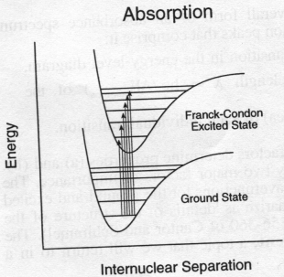
1- Vibrational energy levels
Within the same electronic energy level (or state) there are also vibrational energy levels and rotational energy levels. Most molecules at equilibrium in a given electronic state are in the lowest vibrational and rotational energy levels of that electronic state (This statement is true for chromophores in ground state).
When chromophores are excited by photons, they move to a higher electronic state, but individual molecules will also move to different vibrational (and rotational) energy levels within that electronic state.

This will have a consequence on the absorption spectrum of a molecule, which will include multiple “component transitions” that represent transitions from the lowest vibrational energy level of the ground state to different vibrational energy levels of the excited state. This causes the absorption peak to appear as a series of overlapping peaks or more often as a single broad peak, due to additional effects not discussed in this class.
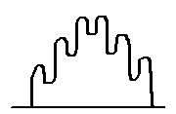
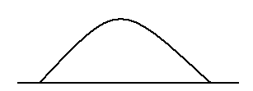

Or, more likely:

The width of these peaks can be around 50 nm.

During the relaxation process, the excited molecules will drop excess vibrational energy (This energy is transferred to the solvent) and move down to the lowest vibrational energy level of the excited state. This accounts for one part of the energy drop during relaxation.

2- Non-optimal dipole interactions
Most chromophores have an electronic dipole, and when they are in a polar solvent at equilibrium, the chromophore and solvent molecules will align themselves such that their respective dipoles are interacting optimally.
When the fluorescent molecule becomes excited by a photon, its dipole changes, and since this absorption occurs on the scale of 10⁻¹⁵ secs, the solvent molecules do not have time to rearrange themselves to accommodate this change (Franck-Condon principle). The result is that some solvent dipoles are now strongly misaligned with the chromophore dipole, which causes the system as a whole to be in a state of excess free energy.
The solvent molecules will then rearrange themselves to better interact with the excited-state dipole of the chromophore. This rearrangement occurs on the order of 10s to 100s of picoseconds.

Remember that all of the events that happen during excitation happen in a “mirrored” fashion upon emission of a photon (For the moment, we will not discuss radiation-less transfer).
1- When the chromophores emit fluorescence, they move from the lowest vibrational energy level of the excited state to various vibrational energy levels in the ground state.
2- Upon emission, the dipole of the chromophores change and are no longer optimally interacting with the dipoles of the solvent molecules, which must then rearrange.

Therefore relaxation occurs after emission as well as after excitation.

The Absorption and Fluorescence spectrums:

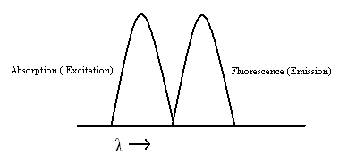
The absorbance and fluorescence spectrums have three characteristics:
1- Both spectrums are broad, because they each encompass multiple energy level transitions (vibrational, rotational, etc.) in addition to a common electronic state transition.
2- The absorption and fluorescence spectrums are rough mirror images of each other, because of the “mirror image” relationship between the two events.
3- The fluorescence spectrum is shifted to longer wavelengths and is typically well resolved from the absorption spectrum. This is due to the fact that the emission event has a lower energy, and wavelength is inversely proportional to energy.

Effects of increased solvent polarity:
An increase in the polarity of the solvent has a number of consequences on the energy levels of the various states:
1- The energy of the Franck-Condon excited state increases.
2- The energy of the equilibrium ground state decreases.
3- The energy of the Franck-Condon ground state increases.
4- The energy of the equilibrium excited-state decreases.

1 and 2 put together mean that the energy of the excitation process (The magnitude of the initial energy jump) increases as solvent polarity increases.
3 and 4 put together mean that the energy of the fluorescence process (The magnitude of the energy drop) decreases as the solvent polarity increases.

This has an effect on the wavelengths of excitation and emission:
As the polarity of the solvent increases, the wavelength of excitation will decrease (it is also said to be “blue shifted”, because the wavelength decreases towards the ultra-violet). Conversely, the wavelength of emission will increase, or become “red shifted”, as solvent polarity increases.

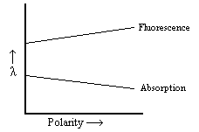
An example of application of this phenomenon would be to extrapolate the environment of a Tryptophan residue by observing whether its absorption and fluorescence spectra become shifted by variations in solvent polarity. This will be discussed further next class.

